Sayem Chowdhury

ID: fr9838

Homework

Assignment # 1

CSC: 2200

Problem(1) (a)

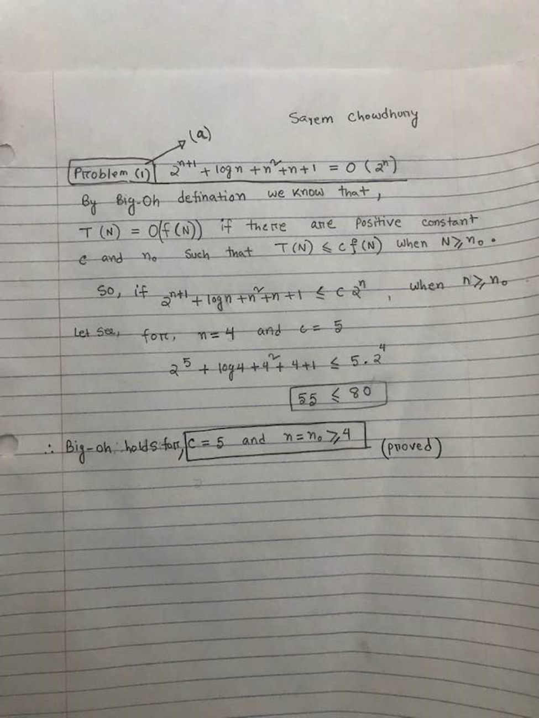

Problem(1) .(b)

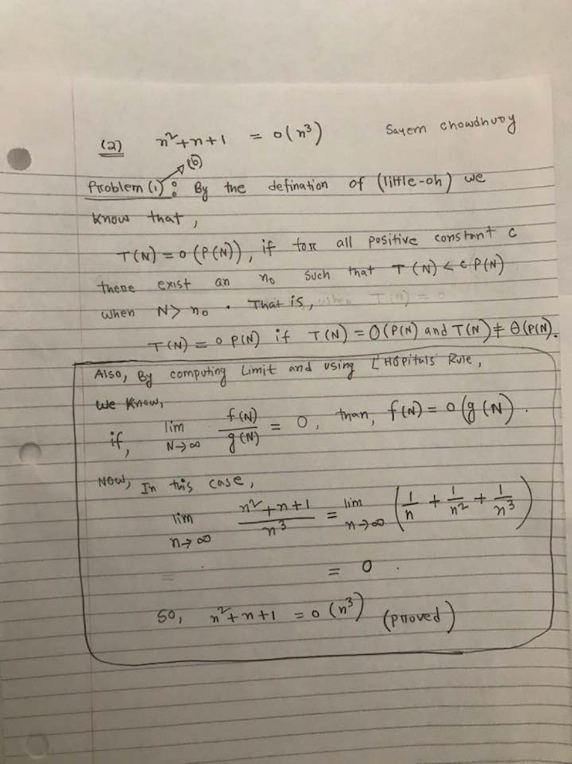

Problem(2)

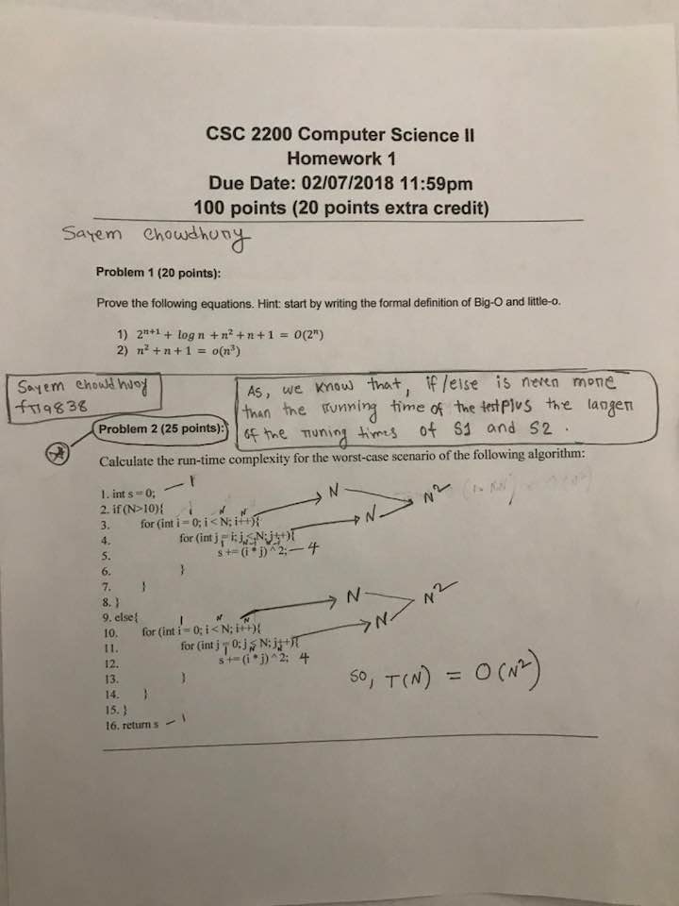

Problem #3 (a)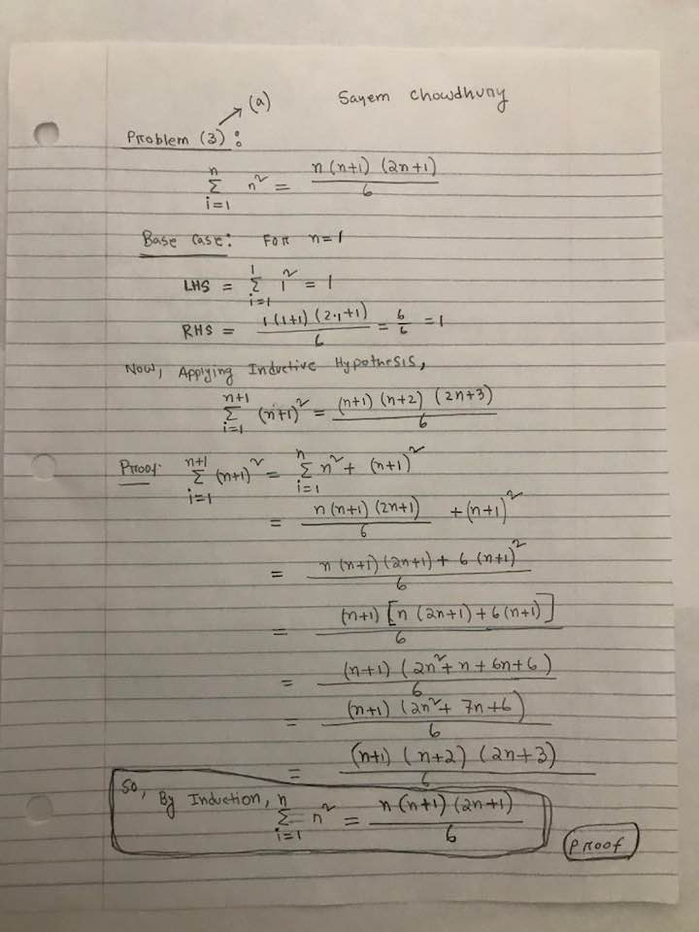

Problem# 3(b)

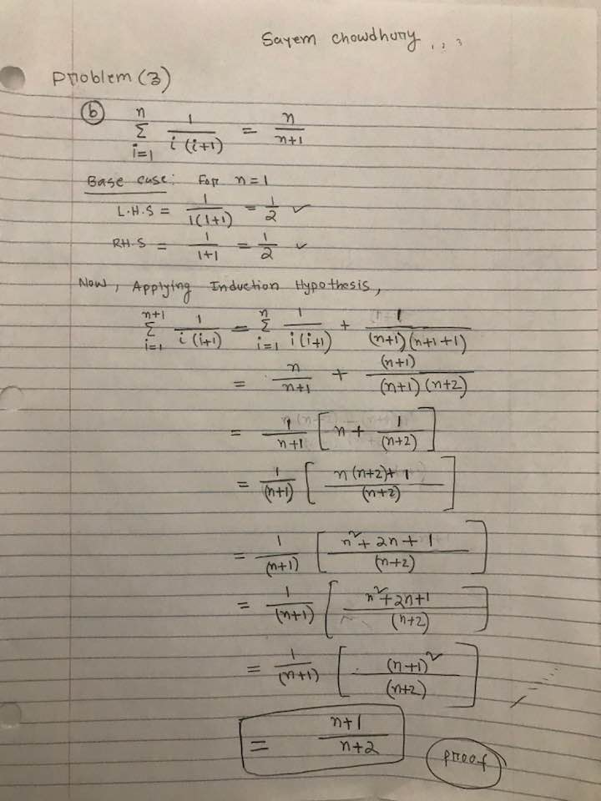

Problem(4):

/*

Sayem Chowdhury

Assignment #(1)

Problem #(4)

*/

#include <iostream>

#include <string>

using namespace std;

//generic Template Class

template <class Type1, class Type2>

class Pair

{

//Public members

public:

Pair(const Type1 & x = Type1(), const Type2 & y = Type2()):

a(x), b(y){}

void set(Type1, Type2);

void print();

//Private members

private:

Type1 a;

Type2 b;

};

//Defination of constructor

template <class Type1, class Type2>

void Pair<Type1, Type2>::set(Type1 x, Type2 y)

{

a = x;

b = y;

}

// defination of set function

template <class Type1, class Type2>

void Pair<Type1,Type2>::print()

{

cout << "Variable 1 is: " << a << endl

<< "Variable 2 is: " << b << endl;

}

//main function

int main()

{

Pair<int, string> obj(1, "one"); // object of the class

obj.print();

obj.set(5, "five");

cout << "After setting \"variable 1\" to 5, and \"variable 2\" to five " << endl;

obj.print();

system("pause");

return 0;

}

Extra Credit:

**(Comments: N and E (epsilon) both goes to Infinity the Growth Rate of N logN is Faster)

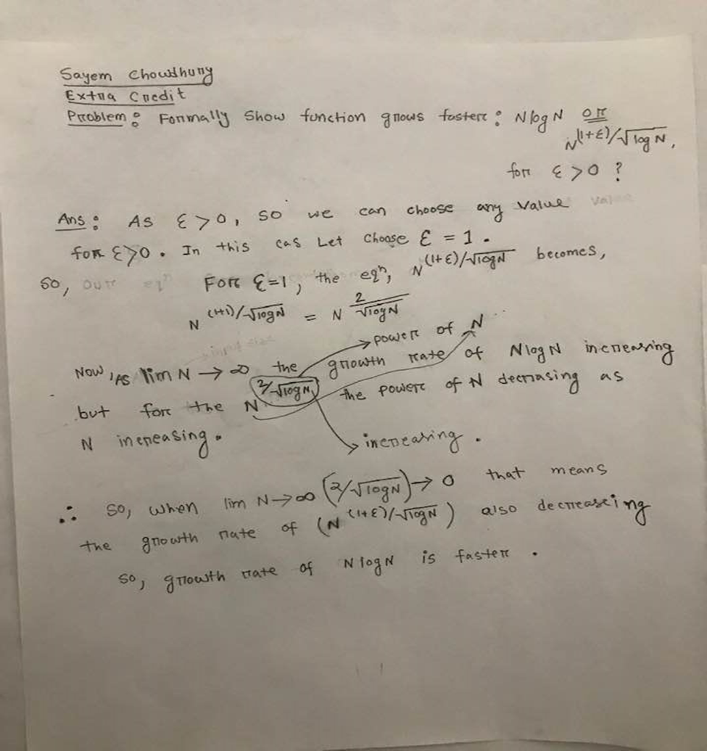

Also, by Analyzing Graph, we can proof that:

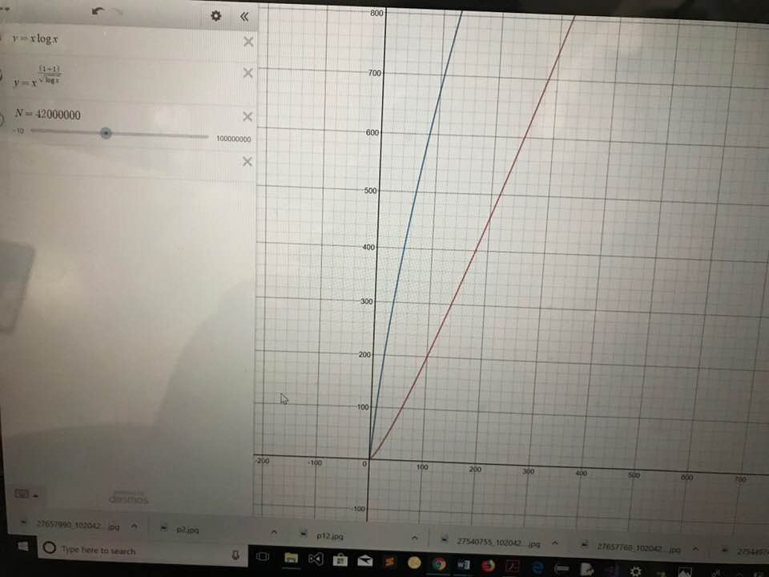

___ N^(1+E)/(logN)^1/2

___ Nlog N

As In the graph When N is not large in number ,the Growth Rate of N^(1+E)/(logN)^1/2 is faster Than NlogN but in the Picture bellow as N goes to infinity the growth rate of N^(1+E)/(logN)^1/2 going down.

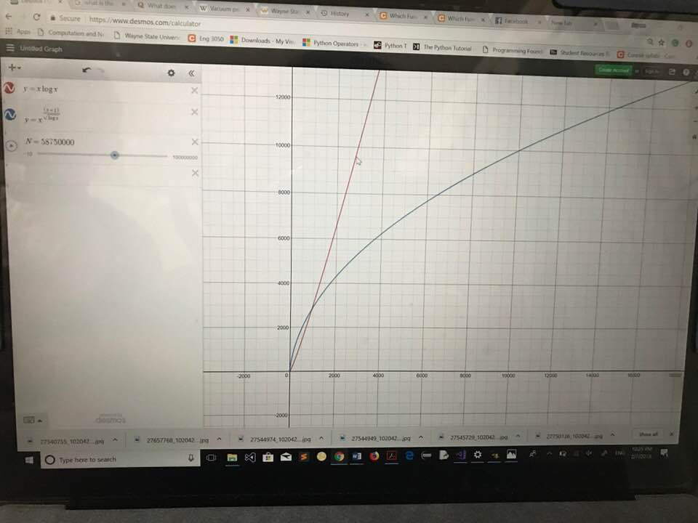

So, growth rate of N logN is faster than N^(1+E)/(logN)^1/2.